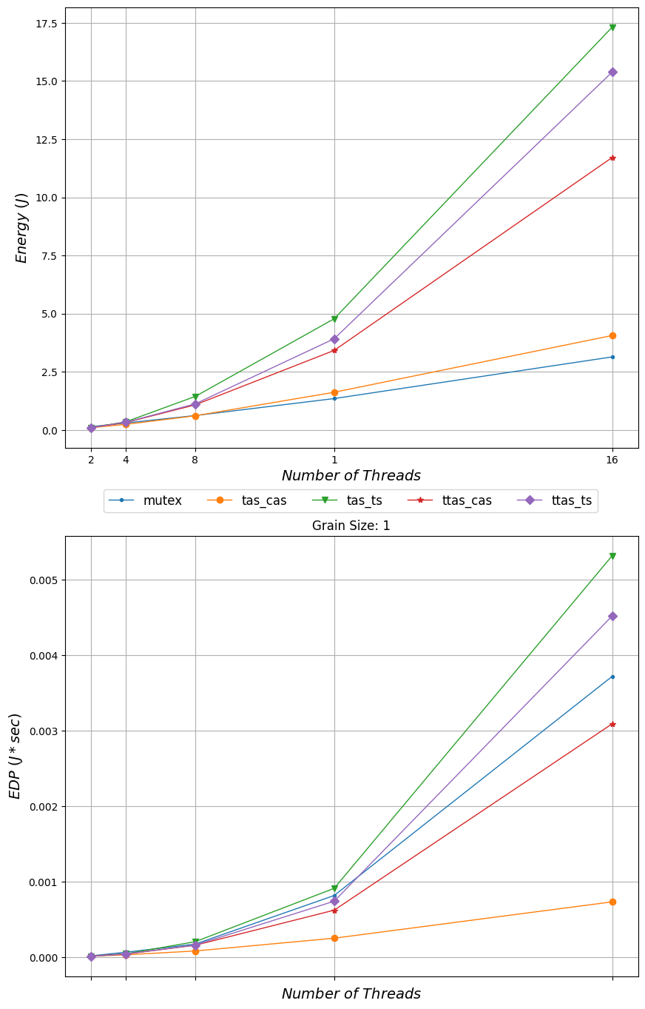

*Energy ()*

24

-

mutex

-

*Number of Threads tas_cas + tas_ts +*

Grain Size: 1

ttas_cas

t tas_ts

0.005

0.0047

*EDP (/* sec)*

0.0017

0.000

*Number of Threads*